HemoSim edit doc - N2
HOW TO USE: edit the wording directly (Track Changes if you like). For layout or a figure (size, position, wrong/missing image) write a short instruction in [brackets] right where it applies. Send it back and I apply the wording to the page and the layout notes to the styling, then regenerate. This is a content+notes doc, so it will not look exactly like the web page.

Oxygen delivery as the organizing principle
The last page left us with a definition, not a measurement: shock is a state in which cellular oxygen use (VO2) is too low to keep the body in homeostasis. The problem is that VO2 is heterogeneous across organs and genuinely hard to quantify. So the whole enterprise of hemodynamic assessment rests on a single organizing idea. Optimizing oxygen delivery (DO2) is the premise of shock resuscitation, because in most patients the fastest way to protect a failing VO2 is to defend the delivery that feeds it. The DO2 is the amount of oxygen the circulation carries to the tissues each minute, and it is simply the product of two things we can reason about: how much oxygen each unit of blood carries, and how much blood flows.
DO2 = CO × CaO2
CaO2 = (Hb × 1.34 × SaO2) + (0.003 × PaO2)
so DO2 ≈ CO × Hb × 1.34 × SaO21.34 is Hufner's constant, the mL of O2 carried by one gram of fully saturated hemoglobin. The dissolved term (0.003 x PaO2) is so small it is normally dropped. Normal DO2 is roughly 1000 mL/min.
Written this way, the equation names the only three levers we hold over global delivery. Hemoglobin sets the carrying capacity, so anemia lowers delivery even with perfect lungs and a strong heart. Arterial saturation is the work of the lungs. And cardiac output is the flow. Of the three, the teaching point worth memorizing is that cardiac output and hemoglobin carry the largest influence on DO2, and cardiac output is the lever we can move most quickly and by the most. That is why the following modules are largely the study of defending cardiac output, and why raising hemoglobin sits alongside it as a direct way to lift delivery.

The extraction reserve, and why a falling delivery hides
Here is the part that is both the physiology and the trap. The tissues do not consume all the oxygen that arrives. At rest they extract only about a quarter to a third of it, which is why normal central venous saturation (ScvO2) sits near 70 to 75 percent. That figure is not an accident: rearranging the Fick relationship, ScvO2 is approximately one minus the oxygen extraction ratio, so the venous saturation is a running readout of how hard the tissues are having to pull. The unused three quarters is a buffer. As delivery falls, the tissues protect their consumption by simply extracting more, so VO2 holds flat and the venous saturation quietly drifts down. Across this range consumption is supply-independent: the patient is compensating, and the surface can look calm.

Crossing critical DO2
That buffer has a floor. Past a critical delivery threshold, extraction cannot rise any further, and now consumption is forced to fall in lockstep with delivery. This is the supply-dependent region: cells switch to anaerobic metabolism, lactate climbs, and organ function begins to fail. This is where observed delivery has dropped below what homeostasis needs (oDO2:nDO2 < 1), the state often called circulatory failure. Everything we do in resuscitation is aimed at keeping the patient above that inflection, usually by defending cardiac output and hemoglobin. The falling venous saturation and the rising lactate are the two signals that the reserve is being spent.
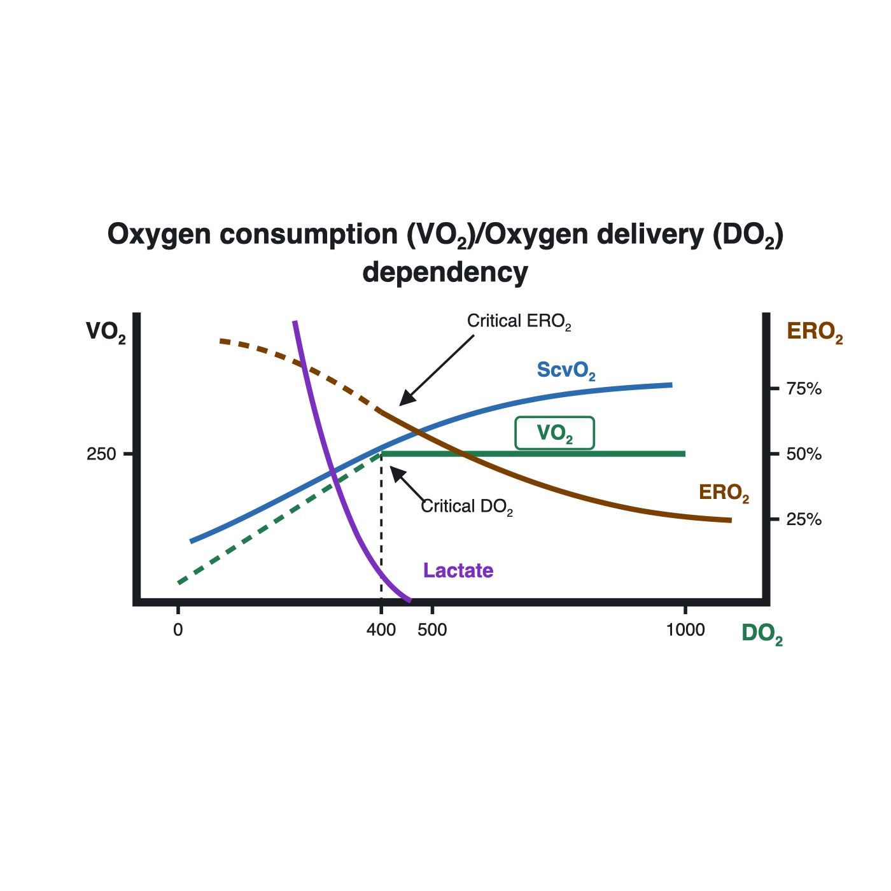
The DO2 / VO2 relationship: consumption stays flat and supply-independent over a broad range as extraction rises, then bends into the supply-dependent limb below critical DO2 as lactate climbs.
[Layout note: figure shown small here. On the web it is currently capped at 640px wide. Say if you want it smaller/larger, moved, cropped, or replaced.]

Reading the reserve without a delivery number
Neither delivery nor consumption appears as a number on the monitor, so the practical skill is to read the surrogates that track them. Two are worth knowing here. The first is central venous saturation itself. Because ScvO2 mirrors extraction, a low value in a sick patient usually means the tissues are pulling hard against an inadequate flow: a potentially reversible, flow-limited state that should respond to more cardiac output, hemoglobin, or oxygenation. But few patients have a PA catheter where a true ScvO2 could be acquired, and ScvO2 is a coupling marker, not a delivery gauge, and many things move it, so a normal or high value does not prove all tissues are well perfused.
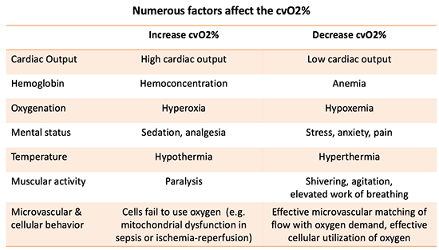
ScvO2 sits at the crossroads of delivery and demand: cardiac output, hemoglobin, arterial saturation, temperature, sedation, and cellular utilization all move it, which is why it is read as a coupling marker rather than a pure delivery number.
[Layout note: figure shown small here. On the web it is currently capped at 640px wide. Say if you want it smaller/larger, moved, cropped, or replaced.]
The second is the tissue's metabolic exhaust. As flow slows, carbon dioxide lingers in the tissues and the venous-to-arterial CO2 gap (Pv-aCO2) widens beyond about 6 mmHg, a fast flow marker that complements ScvO2. And lactate rises. Lactate deserves a caveat even at this level: it is not a pure hypoxia meter. It also climbs with catecholamine-driven glycolysis, shivering, and the metabolic stress of sepsis, and it doubles as a fuel that organs consume, so it is better read as a marker of metabolic stress than of oxygen debt alone. In the setting we care about here, though, a rising lactate alongside a falling ScvO2 is the fingerprint of a delivery that has slipped toward, or past, its critical floor.
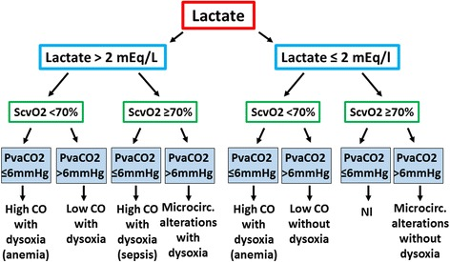
Read together rather than alone, ScvO2 and the CO2 gap separate a flow problem that will answer to more cardiac output from a microcirculatory or utilization problem that will not.Source: De Backer, Crit Care 2017.
[Layout note: figure shown small here. On the web it is currently capped at 520px wide, the default. Say if you want it smaller/larger, moved, cropped, or replaced.]
If delivery can be failing while the labs still look reassuring, we need a fast, structured way to read perfusion at the bedside. That is the method we build next.

References
To DROP a reference, strike it. To ADD one, write [add: author, year, journal, roughly what it is] rather than typing the citation out. Do not correct the text of an entry here: every author list, volume, issue, page range, year and DOI is fetched from PubMed when the page is rebuilt, so an edit made here is discarded and a typo made here is caught. This list is what the page currently carries.
1. Rola P, Kattan E, Siuba MT, et al. Point of View: A Holistic Four-Interface Conceptual Model for Personalizing Shock Resuscitation. J Pers Med. 2025 May 20;15(5):207. doi:10.3390/jpm15050207. Free full text.
2. Polanco PM, Pinsky MR. Practical issues of hemodynamic monitoring at the bedside. Surg Clin North Am. 2006;86(6):1431-56. doi:10.1016/j.suc.2006.09.003.
3. De Backer D. Detailing the cardiovascular profile in shock patients. Crit Care. 2017 Dec 28;21(Suppl 3):311. doi:10.1186/s13054-017-1908-6. Free full text.
4. Bakker J, Coffernils M, Leon M, Gris P, Vincent JL. Blood lactate levels are superior to oxygen-derived variables in predicting outcome in human septic shock. Chest. 1991;99(4):956-962. doi:10.1378/chest.99.4.956.
5. Hernandez G, Ospina-Tascon GA, Damiani LP, et al. Effect of a resuscitation strategy targeting peripheral perfusion status vs serum lactate levels on 28-day mortality among patients with septic shock (ANDROMEDA-SHOCK). JAMA. 2019;321(7):654-664. doi:10.1001/jama.2019.0071. Free full text.

